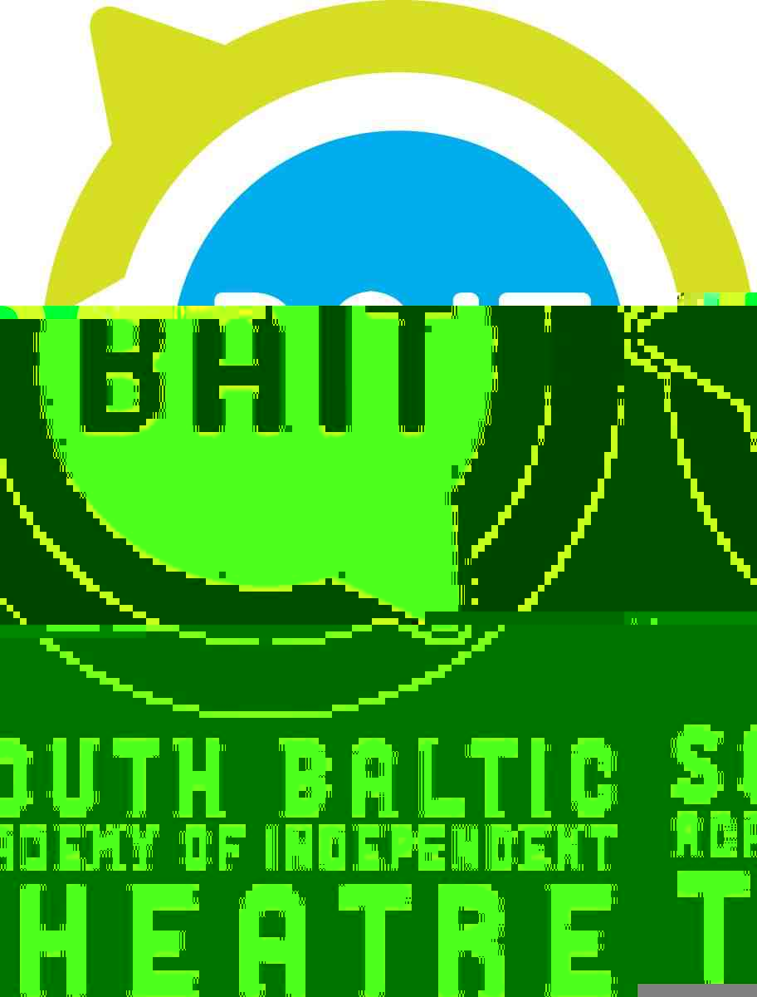
South Baltic Academy of Independent Theatre BAIT and Riksteatern Blekinge
would like to invite
theatre artists, community-engaged artists, theatre instructors and cultural and socio-cultural leaders to the conference summarizing the activities of the project and presentation of the e-book with project methodology.
Date: 20th November 2014
Place: “Lokstallarna”, Smedjan hall, Prinsgatan 43, 374 33 Karlshamn
Hours: 10.00 – 16.00
Admission: free
Subject:
The conference is aimed as a meeting of professionals who works in theatre, community-engaged art, cultural and socio-cultural activation, as well theatre leaders who work with youth and marginalized societies. It’s goal is to present the methodology and achievements of the three-year educational project “South Baltic Academy of Independent Theatre – a Tool of Social Change”, realized from 2012-2014 in Poland, Sweden and Lithuania. The conference would be an opportunity to exchange the professional and personal experience and to discuss about possibilities of adaptation of this methodology in other regions of Europe.

About the project:
„South Baltic Academy of Independent Theatre – a Tool of Social Change” is an international socio-educational-artistic project, co-financed by South Baltic Programme. Its implementation involves the partners from Lithuania, Sweden and Poland. Among participants are young Polish, Swedish and Lithuanians.
Who is involved in the project?
Enthusiastic young people who want to make a difference in the cultural life of their city and their region. By various theatrical methods, such as exercises developing awareness of the body, vocal and voice exercises, dance, puppetry, street theatre, history of theatre and drama, animation of culture and elements of psychology, we are teaching our students not only how to create, but also how to independently plan and implement cultural projects.
The meetings have been held both in Poland (Sopot/Gdynia) and Lithuania (Klaipeda) on monthly basis and one of them took place in Karlshamn, Sweden. Each academic year is concluded by diploma performances of the students, which were presented in Lithuania, Poland and in Sweden.
During the third year, the students were asked to verify their abilities, as they conducted their own workshops with group they were responsible for recruiting. Each of the students was also asked to write a cultural-animation project and prepare the independent work of art, such as: a directed theatrical performance, a happening, a short-film, a dramatic reading, a written drama, a written stage adaptation of literature.
The main goal of the project was educating the next generation of young, independent and brave theatrical artists and community-engaged artists as well as community and social leaders, who in the future, with a great passion, will influence the environments in which they live and work. Owing to the project we will also be able to test innovative methods of creative and social activation work of the South Baltic Region. The methods is gathered in an electronic publication, which constitutes a collection of practices and methodologies ready to be adapted in other regions of Europe.
The schedule:
10.00 – 10.30 – welcoming and short presentation of “South Baltic Academy of Independent Theatre” project goals
10.30 – 11.15 – presentation of documentary movie about the project’s realisation
11.15 – 11.45 – “Meeting the graduates” – Swedish and Polish BAIT student share their experience
11.45 – 12.00 – coffee break
12.00 – 12.30 – “Teaching experience” – Swedish lectors share their experience with BAIT
12.30 – 13.00 – “The Partnership” – Swedish, Polish and Lithuanian partners describe their role and organisational benefits they achieved during project’s implementation
13.00 – 13.30 – “Methodology” – presentation of e-book publishing the methodology and detailed implementation of the project
13.30 – 14.00 – “Methodology adaptation” – questions, answers and discussion
14.00 – 15.00 – lunch break
15.00 – 16.00 – “What Has Gregor Dreamt About, That He Overslept” – II year diploma performance, staged by BAIT students, directed by: Christoffer Simebjär Tagesson (SE), Alessandra Cali (IT), Arūnas Mozeris (LT), artistically supervised by Ewa Ignaczak (PL)

Organizers:
Riksteatern Blekinge (Karlskrona), Baltic Artistic Agency BART (Sopot), Klaipeda State Music Theatre (Klaipeda)

Conference is organized as a part of “South Baltic Academy of Independent Theatre – a Tool of Social Change” project, co-financed by South Baltic Cross-border Co-operation Programme 2007 – 2013, Ministry of Culture and National Heritage of Republic of Poland, Ministry of Internal Affairs of Republic of Lithuania, Municipality of Sopot.

