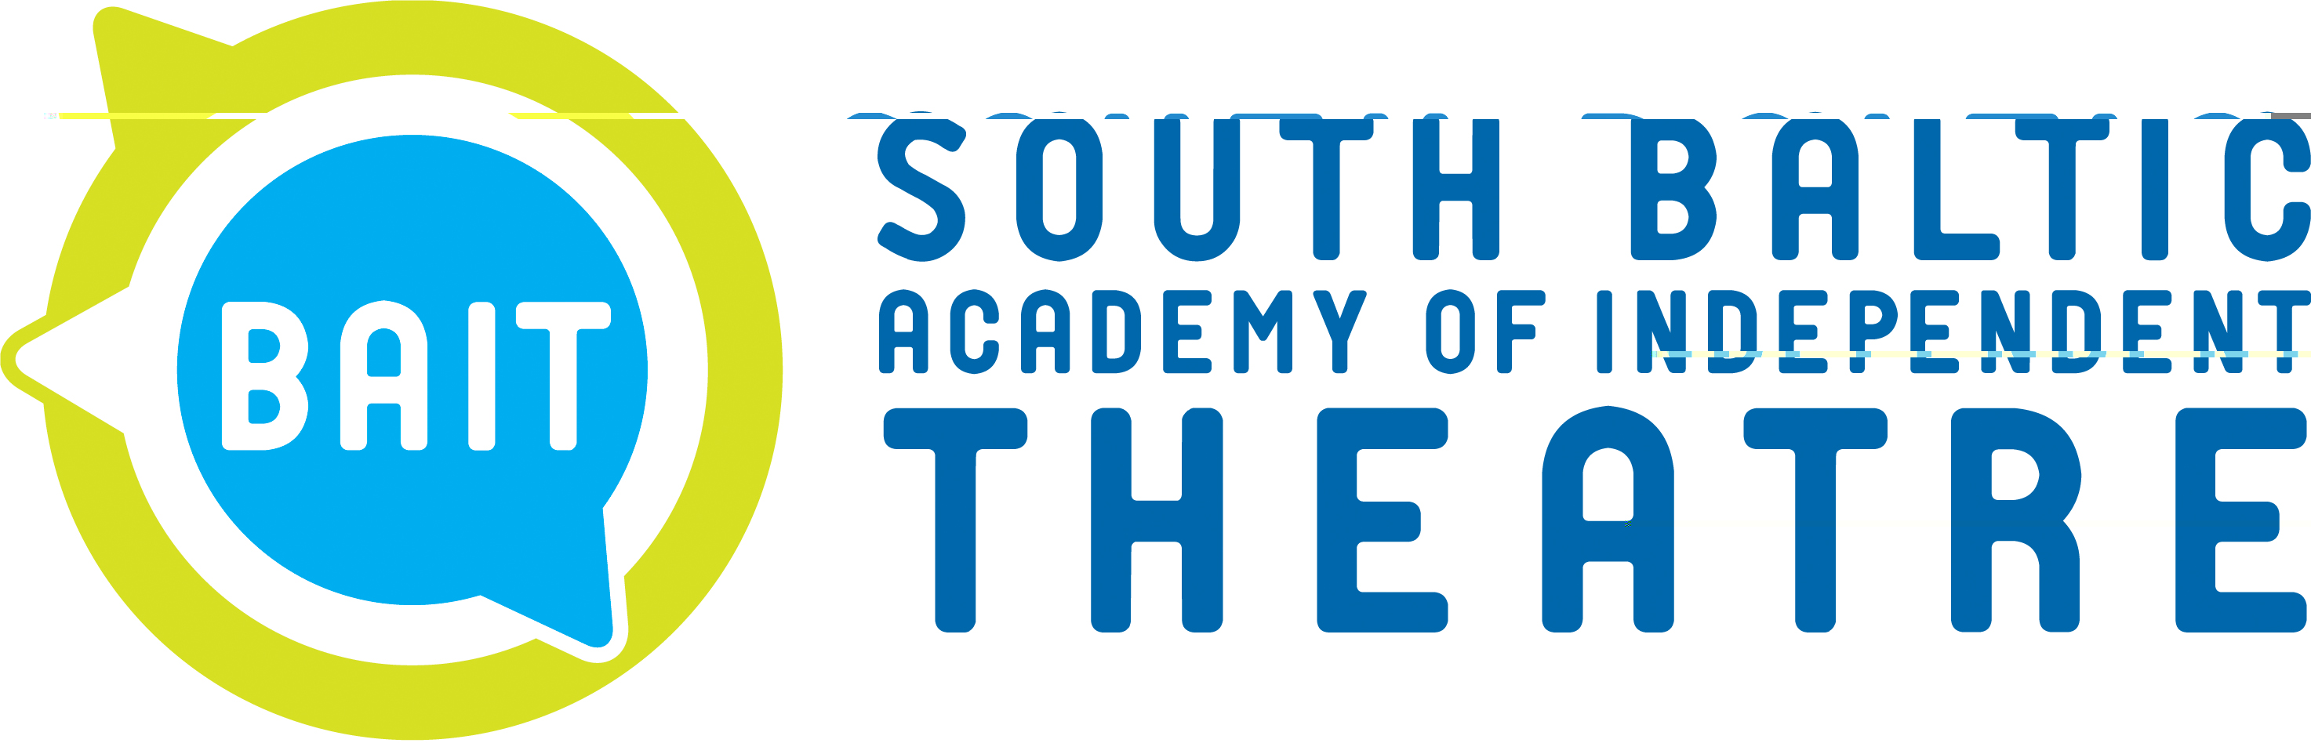
…...............................
Place and date

Workshop Evaluation Questionnaire
Workshops conducted by ………………………………………………………………………….,
^{(name and Surname)}
on ………………………………………………
^{(dates)}

- How interesting were the classes*:

5 – very interesting
4 – interesting
3 – quite interesting
2 – rather uninteresting
1 – uninteresting

- How professionally were the classes conducted*:

5 – very professional
4 - professional
3 – quite professional
2 – rather unprofessional
1 – unprofessional

- Did you learn anything new*?

5- definitely yes
4- rather yes
3- partially yes, partially not
2- rather not
1- definitely not

- The atmosphere of the classes was*:
5- great
4- good
3- average
2- rather not good
1- bad

* Circle your answer

- During the classes did anything bring you satisfaction, if yes what was it? …......................................................................................................................................................................................................................................................................................................................................................................................................................................................................................................
- During the classes was anything difficult, if yes, what was it?
…......................................................................................................................................................................................................................................................................................................................................................................................................................................................................................................
- Would you change anything in the way the workshop was conducted, if yes what was it?
…......................................................................................................................................................................................................................................................................................................................................................................................................................................................................................................
- Were you informed that the workshop was conducted as part of the „South Baltic Academy of Independent Theatre – a tool of social change” project*?

Yes/No

Thank you for expressing your opinion!

